The research on the effects of the widespread use of electric vehicle
Abstract（Summary）:
As the appear of electric vehicle, the advantages of it may reduce the tense of energy source, but the suspicious of it’s environmental also appeared. This essay using AHP, building a model to analysis the effaces of electric vehicle about mainly aspects.
According to the four requirements given in question, we analysis the electric vehicle synthetically. At the first requirement, we set three index: energy ration, pollution cost, and one year cost. Using the three index we building a AHP model to analysis the efface that electric vehicle can make in environment, society, economic and health. And we work out that electric vehicle is better than motor vehicle by the end result and supporting the widely using of electric vehicle and give some suggests to government and manufacturer. At the second requirement, using the data of first requirement, we calculate the gross of energy sources can save by widely using electric vehicle is 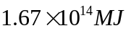 which accounted for 33.2% of global energy sources. At the third requirement, we calculated the gross of electricity that the plants should generated for electric vehicle is 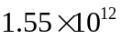degrees. And we also building a AHP model to analysis the best ratio of 4 kinds of electric vehicles and 4 kinds of material that used to generated electricity. We get the best ratio of electric vehicles is the fuel cell vehicle, the electric vehicle and the hybrid electric vehicle respectively accounted 44.69%, 36.66%, 18.98% of gross of electric vehicle and the best ratio of material is Coal, Gas, Nuclear, H power and others respectively accounted 1.6%, 23.62%, 22.32%, 26.67%, 20.15% of electricity net generations. And at the last requirement, we analysis the most aspects of the electric vehicle can affect including the pollution of power generation and waste batteries. We also give some suggests about the development of electric vehicle.
At the end of this essay, we comment our model’s advantages and disadvantages. And given some suggests about how to make our model better.
Key words: AHP Judgment Matrix Resource Allocation Hierarchical optimization

Content
1. Introduction & Backgrounds
  - Conception …………………………………….……………………………….…………....………….4
1.2 Min Type……………………………………………………………………………………....…………4
1.3 Charging equipment……………………………………………………………………....…….……5
1.4 Characteristics of Equipment…………………………………………….………….....………….5
1.5 Condition of development………………..………...………………………………........…...7
1.6 Prospects…………………………………………………………………………........…...7
- The Description of Problem（Problem Analysis）
  - Requirement 1: Analysis od electric vehicle and motor vehicle....................................8
  - Requirement 2: Estimate how much oil(fossil fuels) the world would save by widely using electric vehicles…………………………………………….……...…….8
  - Requirement 3: Analysis the amount and type of electricity generation use to electric vehicle that will produce the largest number of benefits..…………...…….…9
  - Requirement 4: Analysis report………………………………………...………..…9
- Models
3.1 Symbols and Definitions…………………..……..…...……………………….........……...10
3.2 Assumptions………………………………...…………………….……..……….........…….10
3.3 The Foundation of Model………………………….…………………………….........….10
3.3.1 Model of Requirement 1: comprehensive analysis of EV and MV.............11
3.3.2 Model of Requirement 2: how much oil that EV can save in the world.....21
3.3.3 Model of Requirement 3: The most beneficial amount of power and type of case...................................................................................................................................................23
3.3.4 Model of Requirement 4: For electric vehicle battery problem.................29
3.4 Improved Model…………..............................................................................32
- References.....................................................................................................................................34
- Appendix.......................................................................................................................................34
Programs and codes........................................……………………………..……………………35

I. Introduction & Backgrounds
In order to indicate the origin of electric vehicle, the following background is worth mentioning.
1.1 Conception
the electric vehicle(EV) is a car that being powered by a car power, driving the wheel by using the motor, comply with the road traffic safety laws and regulations requirements. Because the relatively smaller environmental pollution compared with traditional car , the prospect is cheerful. But the technology is immature currently.
1.2 Main Type
Battery Electric Vehicle(EV) , Hybrid Electric Vehicle (PHEV), Fuel cell vehicles(FCEV)

1.2.1 The Battery Electric Vehicle（EV）
The Battery Electric Vehicle is a car that being powered by motor. It use super charging station compared with Gas station.

1.2.2 The hybrid electric vehicle（PHEV）

Hybrid cars refers to at least from the following two types of on-board storage energy car:
Consumption of fuel or Rechargeable/energy storage devices
The hybrid electric vehicle

1.2.3 The hybrid electric vehicle（FCEV）
The Fuel cell vehicles is a car that powered by fuel cell.

1.3 charging device
Motor driven electric energy storage sources in vehicle rechargeable or other energy device. The power of motor have no harmful gas emission , even if which converts to the emission of power plants except the sulfur and PM , the emission reduced observably.
The electric vehicle also could charge in the night low power , make sure the generation equipment could make full user of , to improve the economic benefit. Because of these advantages the research and development about electric vehicle become a lot.

1.4 Characteristics of Equipment

1.4.1 No pollution, low noise
the electric vehicle don’t produce waste gas and exhaust pollution when it works , to the environmental protection and clear air is very good, almost zero pollution. As everyone knows, the CO, HC,NOX,PM and stench come from the exhaust gas diesel locomotive result in Acid rain and photochemical smog smoke. The electric vehicle have no noise compared with internal combustion engine, noise is bad of people’s Hearing, cardiovascular, digestive, nervous, endocrine, immune system.

1.4.2 Energy efficiency is high, diverse
the research about electric vehicle shows that, the energy efficiency of electric vehicle have exceed petrol motor car. Especially in the city. the car stop and go frequently, take a low speed, which suit electric vehicle. On the other hand, the extensive use of electric vehicle could reduce the depend on the oil, we could use the limited oil to do something more important. The power that charge the battery could be transformed from coal, natural gas, hydro, nuclear, solar, wind, tidal . In addition, if we charge battery in the night, avoid peak hours, to the benefit of the balance of power network , reduce costs.

1.4.3 High power cost Short mileage
the technology about electric vehicle is not perfect compared with the technology about ICE Vehicle, especially, the lifetime of the battery is short, it’s expensive. Because of the storage of the battery is short, a short mileage after one charge. the price of electric vehicle is expensive, but from the perspective of development , as long as the development of technology, this problem will be solved if we muster humans and resource. Enhance advantage and avoid disadvantage electric cars will gradually popular, its price and the use of the cost will inevitably reduce.

1.5 Condition of development
The famous automobile manufacturers all over the world are stepping up the development of various types of electric vehicle, and acquire some progress and breakthrough.

1.6 Prospects
Energy and environment problems, climate change is a long-term problem of human society has to face. The greenhouse gas emission, energy consumption and emissions of three big questions in the transport sector is an effective solution to the problem directly affects the common human effectively solve. Therefore, the major governments, organizations, car manufacturers, energy providers, venture investment enterprise in the world act together. To promote the upgrading of the industrial structure of global automobile industry and electric power system strategic transformation. To promote the social basis of the electric car industry has a multi-level structure of the formation and the corresponding policy, organization guarantee system construction, boost the formation of social sustainable development of electric vehicle.

II. The Description of the Problem（Problem Analysis）
The title require us to study two problem :“How environmentally and economically sound are electric vehicles? Is their widespread use feasible and practical?”, And gives us seven issues to be considered，Finally, the answer to the question should reach 4 requirements.
2.1 The first requirement: Comprehensive analysis of electric vehicles and motor vehicle
The first requirement asked me to use large amounts of data to analyze if we should support the development and use of electric vehicles from the environment, social economic and health impacts. Also recommendations to the government and electric vehicle manufacturer should be given. We chose three representative indicators which are the efficiency of energy from source to vehicle (EESV), vehicle’s cost per kilometers of one year (CKOY) and the cost of pollution treatment (COPI), taking the example of AudiA6 and Tesla, and use Analytic Hierarchy Process (AHP) to judge motor vehicles and electric vehicles’ advantage and disadvantage in these four areas.
2.2 The second requirement: oil-saving in global by widespread using EV
The second question requires we calculated that when after the widespread use of electric cars, we could save the mount of fossil fuel all over in the world. In the first question, according to the original fuel efficiency index we can get that under the condition of energy optimal electric vehicles, the proportion of the number accounts for the total number of cars, we use the data in 2011 to be an example, we calculated that before the widespread use of electric cars ,the amount of total energy consumption in the world, and also we can get that data after the widespread use of electric cars .Finally, we obtained the amount of oil that is saved ,and the proportion of the saved oil.
2.3 The third requirement: The maximum amount of power and type of case for the benefits of electric vehicles
The third problem requires us to calculate the distribution of electric vehicles in the number and variety of maximum benefit to all aspects of the next generation, types and quantity required .The same is in 2011 as an example, use the first asked the weights obtained comprehensive benefits than to determine the required number of electric cars, and then the analytic hierarchy process to determine the proportion of pure electric vehicles, hybrid electric vehicles and fuel cell vehicles, finally according to the different models of the electricity calculated within one year of the total electricity.
2.4 The fourth requirement：Analysis Report
Finally, we through a lot of calculation evaluation, prediction, found that use of electric cars can bring many benefits, but also faced with some problems at the same time, to solve these problems, we based on the data gives some reasonable solution.
III. Models
3.1 Terms, Definitions and Symbols
Table 1 Terms, Definitions and Symbols
Symbol | Meaning
 | Ton
 | Distance
 | Work
 | Weight
 | Coefficient of friction
 | Consistency Index
 | Mean Random Consistency Index
 | Consistency proportion
 | MJ=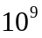J

3.2 Assumptions
- In this paper, the specific data relating to motor vehicles and electric vehicles were taken from the Audi A6 and Tesla
- Assuming the same weight of motor vehicles and electric vehicles, are 1
- within a small time , the car number is the same in all over the world, car type is stable.
- All statistics and sampling authentic sample to reflect the overall characteristics.
3.3 The Foundation of Model
3.3.1 Model of Requirement 1: comprehensive analysis of EV and MV
For decide whether should I support the widely use of electric vehicles, we put forward there indicators to model the environmental, social, economic, and health impacts.
Indicators 1: The efficiency of energy from source to vehicle(EESV)
The efficiency of energy from source to vehicle(EESV) to show the loss of energy. As shown in figure 1, minus the loss of oil refining, coal burning, transmission at grid and electrical or oil machine, we consider the energy from the source like oil or
coal to the end use for vehicle. And the EESV is the ration of initial energy and energy used by vehicle.
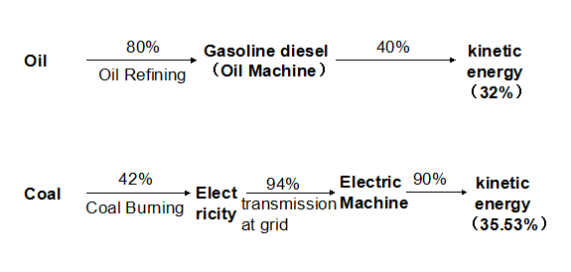
Figure 1. The efficiency of Energy
In order to understand the EESV of electric vehicle and motor vehicle, we use Audi A6 and Tesla as the example.
Use to show how much energy the fuel containing. And the EESV can shown by journey(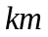) that per initial energy() can run. The more the journey, the higher the EESV. Use the EESV of electric vehicle and motor vehicle given by figure 1, and the expression
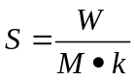
(Theis friction coefficient of general tire and general road. It’s values is 0.7.) we calculate the journey() that per initial energy() can run. The results are shown in Table 2:
Table 2. 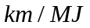of electric vehicle and motor vehicle
Types | Examples | Initial fuel | EESV
Motor vehicle | Audi A6 | Oil | 32% | 0.46
Electric vehicle | Tesla | Coal | 35.53% | 0.25
According to the result we calculated, we can see the energy of coal be crude refined, be sent to power plants, be charged into battery, and then driving the electric vehicle. It’s EEVS is higher than oils’, which be refined to gasoline or diesel, then driving the motor vehicle by oil machine. Therefore the electric vehicle can save energy sources.
Indicator 2: Vehicle’s cost per kilometers of one year(CKOY)
Now we contrast electric vehicle and motor vehicle from the economic aspect.
In this part，we also use Audi A6 and Tesla as the example of motor vehicle and electric vehicle respectively. We find the price and cost for maintenance per year about the two cars from website^{[1]}.And we know each vehicle driving 2000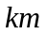per year from ANWB^{[2]}. According to the following expression
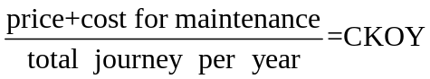
The result and some information of vehicles shown in table 3.
Table 3. Information of Audi A6 and Tesla
 | Motor Vehicle | Electric vehicles
Representative models | Audi A6 | Tesla
Price | 600 thousand | 700 thousand
The annual trip | 20000km | 20000km
Car maintenance costs on fuel | 29565 | 14596
Year unit cost car trip | 31.28 | 35.72
As is shown in table 3 given above, electric vehicle’s CKOV is higher than motor vehicles’ .This is because of the high price of electric vehicle. But EV’s maintenance cost is less than MVs’. We think the gap of CKOV will disappear even upside down in the future.
Indicator 3: The cost of pollution treatment（COPT）
This indicator is used to estimate the total cost which is used to deal with all kind of emission pollution of vehicles.
The emission pollution of motor vehicle mainly from exhaust. Although electric vehicle have no exhaust which pollute environment directly, electricity generation can produce a great of pollution. Especially generation by fossil fuel can produce many carbide and sulfide which are harmful for the air. We assume that the electricity for electric vehicle all come from generation by fossil fuel, and the emission pollution of EV and MV are same.
According to a website^{[3]} we can see the COPT of MV is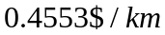. And from the Annual Energy Review 2011 we can see there are 26.48 quadrillion but electricity generated by fossil fuel in all the 40.04 quadrillion but electricity of America. The rate is 66.13%. And the rest electricity are generated by other energy source which hardly produce pollution.
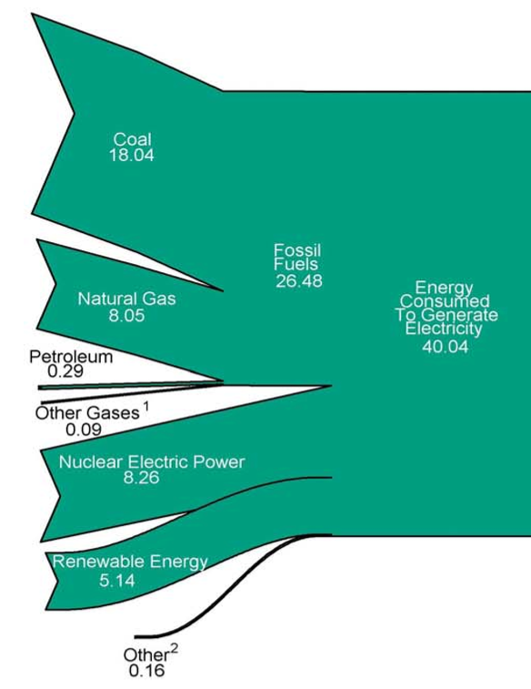
Figure 2. Energy consumed to generate electricity
Because the electricity generation from fossil fuel produce many pollution, and the other generation hardly produce pollution, we assume the 66.13% of electricity for EV come from fossil fuel generation and the rest come from other clear energy generation. Therefore the total COPT is:
And we can see the COPT of EV is less than MVs’.
The net, we use the three indicators we calculated above to analysis how EV affect the environment, society, economic and healthy.
Analytic hierarchy process (AHP) is a method which resolve elements that always related with decision to target, standard, project and so on, then make qualitative and quantitative analysis. This method use network system theory and multi-objective comprehensive evaluation method, put forward a hierarchical weight decision-making method. The characteristics of AHP is based on the deep analysis of nature, efface factors and inside relationship of the complex problem, using less quantitative information to make the thought process of decision mathematical, thereby support simple decision method to complex problem that have multiple target, multiple standard or have no structural characteristic. Especially suit for the occasion that hardly to measure the result of decision problem directly and accurate.
The basic theory of AHP is assess project, effect factors and so on, according to target, standard with ladder structure, determine decision matrix by comparing one-by-one, and then make the component of the largest eigenvector of decision matrix as the corresponding coefficient, and give the weight of project(degree of optimizing) comprehensive. AHP have high reliability and small error because this method let evaluators controlled the relative importance function table and give importance degree of comparing one-by-one. At present, AHP be used widely in many field as a kind of tool that qualitative and quantitative.
And how to determine the value of 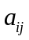 , Saaty and others advice reference number 1 to 9 and their bottom as scale. Table 4 give the meaning of scale 1 to 9:
Table 4. The meaning of scale
Scale | Meaning
1 | Compared tow factors, they have same importance
3 | Compared tow factors, the former is more important than the latter slightly
5 | Compared tow factors, the former is more important than the latter obviously
7 | Compared tow factors, the former is more important than the latter mightily
9 | Compared tow factors, the former is more important than the latter extremely
2, 4, 6, 8 | The middle value of neighbouring judge
Reciprocal | If the specific value of and  is , the specific value of and is 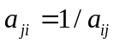

Firstly, we assume the four aspects have same effect on the total benefit. If we put the three indicators on the third floor, put environment, society, economic and healthy on the second floor, and put the total benefit on the first floor, as it’s shown in figure 3.
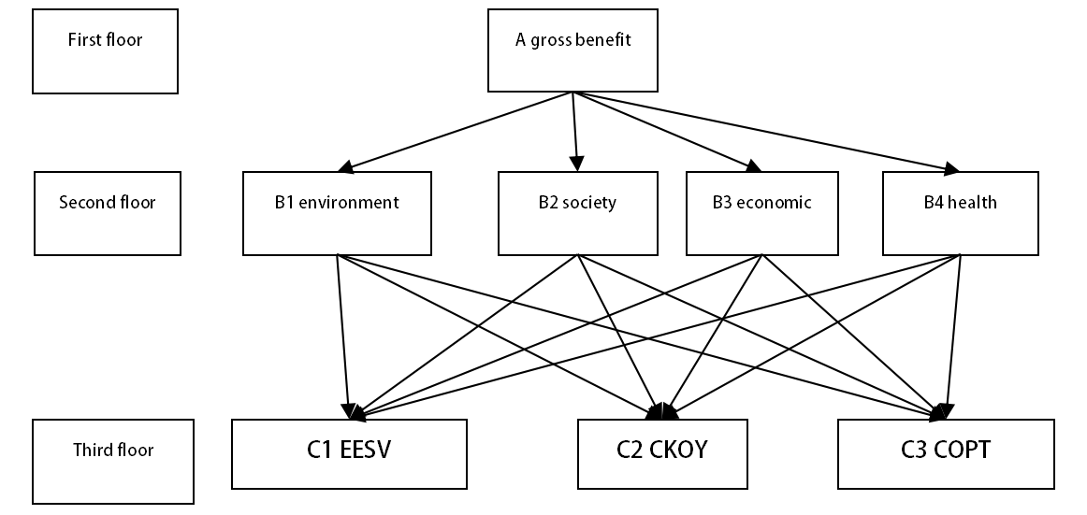
Figure 3. Analytic hierarchy process(ahp) of Vehicle’s total benefit
According to the assumption of the model, the four aspects in the second floor make same efface to the first floor, and we can get the judgment matrix of the second floor is:
Table 5. the judgment matrix of the second floor
A | B1 | B2 | B3 | B4
B1 | 1 | 1 | 1 | 1
B2 | 1 | 1 | 1 | 1
B3 | 1 | 1 | 1 | 1
B4 | 1 | 1 | 1 | 1
According to the physical truth, we set the decision matrix of the third floor. As it’s shown follow:
Table 6. the decision matrix of the third floor
B1 | C1 | C2 | C3 |  | B2 | C1 | C2 | C3
C1 | 1 | 1/3 | 3 |  | C1 | 1 | 3 | 1/3
C2 | 3 | 1 | 9 |  | C2 | 1/3 | 1 | 1/9
C3 | 1/3 | 1/9 | 1 |  | C3 | 3 | 9 | 1
B3 | C1 | C2 | C3 |  | B4 | C1 | C2 | C3
C1 | 1 | 3 | 1 |  | C1 | 1 | 1/3 | 3
C2 | 1/3 | 1 | 1/3 |  | C2 | 3 | 1 | 9
C3 | 1 | 3 | 1 |  | C3 | 1/3 | 1/9 | 1

According to the relevant matrix given above, we can calculate consistency ratio . Firstly we calculate the largest eigenvalue of paired comparison matrix A

And then, according to the formula given follow
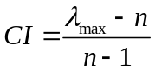
We can calculate consistency index
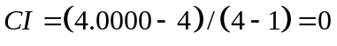
And then we look up corresponding average random consistency index . For 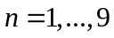, Saaty give the value of , as it’s shown in table 7.
Table 7. The value of
N | 1 | 2 | 3 | 4 | 5 | 6 | 7 | 8 | 9
 | 0 | 0 | 0.58 | 0.90 | 1.12 | 1.24 | 1.32 | 1.41 | 1.45
And we can see

We get the value of in this way: using random method constructed 500 sample matrix, and then extracted number from 1 to 9 and their reciprocal randomly to constructed reciprocal matrix, and calculate the average of the biggest characteristic root 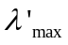 and defined
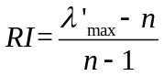
And then according to the , we can calculate the :
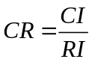
That is
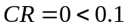
When , we consider the corresponding of judgment matrix is accepted, it’s meanings A pass the consistency check.
For paired comparison matrix, we can calculate the weight vector of level total sorts and make consistency check. The result is shown in table 8:
Table 8. the weight vector of level total sorts
 | CI | CR | W
B1 | -2.2204e-16 | -3.8284e-16 | {0.2308,0.6923,0.0769}
B2 | 4.4409e-16 | 7.6567e-16 | {0.2308,0.0769,0.6923}
B3 | 2.2204e-16 | 3.8284e-16 | {0.4286,0.1429,0.4286}
B4 | -2.2204e-16 | -3.8284e-16 | {0.2308,0.6923,0.0769}
According to the dates given above, we can see the B1, B2, B3 and B4 pass the consistency check.
And then, we calculate the weight value of level total sorts. The weight value of C1 to total target is:
In the same way we can get the value of C2, C3 respectively is: 0.4011, 0.3128.
Synthesize the AHP given above, we can get the table 9:
Table 9. The average consume weight value(ACWV) of EV and MV by AHP
 | EESV | CKOY | COPT | ACWV
Weight value | 0.2801 | 0.4013 | 0.3183
MV | 0.6479 | 0.6019 | 0.4669 | 0.5722
EV | 0.3521 | 0.3981 | 0.5331 | 0.4278

According to table 5, the weight value of CKOY is maximal, it’s meanings CKOY affected the total benefit mostly. In our calculate process, the higher the EESV, the batter the result. Therefor, we set the index 1 is reciprocal. And the lower the ACWV we calculated, the batter the vehicle. So the result is obviously: EV is batter than MV.
According to the analysis above, we think we should support widely using EV. Not only EV can use crude fuel higher, but also it’s less emission pollution. We believe the tow aspects advantages can be more obviously as the development of technology. It is benefit to environment protection and saving energy source. In the short-term, the cost of EV is higher than MV, mostly because the EV’s high price, but the cost of maintain is less than MV’s, so the total cost of EV will be less than MV’s in the long-term. And our model use the most advanced EV - Tesla, which price is 700 thousands, as the example. If the technology of EV are more advance and the quantity of EV is more and more, the price will be lower and lower and must lower than MV’s at the end and replaced MV in the future.
If want to generalize the EV, the think the government and manufacturer should consider the follow factors:
1. Government should support power generation industry reform. At the one hand, improve the energy use ratio of fossil fuel in power generation. At the other hand, improve the ratio of new energy generation. Therefor it can reduce the emission pollution from electric generation.
2.EV manufacturer should focus on environmental and non-toxic battery, deal with the subsequent pollution of EV. It’s include capacity, security, charging velocity, usability, the environmental and security of making, conversion efficiency of electric machine, recovery efficiency and other technical problem.
3.Aim at the high price of EV at the present, manufacturer should improve technology of production, reduce the cost of production and sealing. At the same time, promote the long-term benefit of EV activity.
4.Government should encourage people to buy EV and support corresponding subsidy to consumer.
5.Government should complete the building of the charging station grid for user’s convenience in the future.
3.3.2 how much oil that EV can save in the world
From analysis of the first question we can conclude that VE should be promoted. Whether it is economic, environmental pollution or energy efficiency, EV is superior to MV, which means more energy could save by using EV in all over the world. As for the question that let EV instead of all MV, we can get the answer from AHP in last section. When the proportion of EV and MV is 0.4217 to 0.5722, it can achieve the best results. If we only consider energy saving, the proportion is 0.3521 to 0.6479. So we take these two proportions to estimate how much oil the world would save by widely using EV.
From the following formula
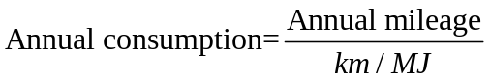
We can calculate energy consumption of a MV and an EV per year, as table 10 showing
Table 10. Calculation of MV’ and EV’ energy consumption per year
 | Km/MJ | Driving distance per year | Energy consumption per year
EV | 0.46 | 20000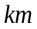 | 43478.26
MV | 0.25 | 20000 | 80000
By researching correlated data we know in 2011the total of car in worldwide is one billion and the EV is 74400, accounting for 0.00744% which is so small that can be neglected. So we suppose all the transportation energy consumption is from MV in 2011. As it shown in table 6 we get the amount energy consumption for transportation is.
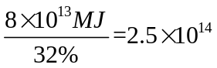
Data obtained above is the direct use of the total energy of the car, namely gasoline (diesel). But if we want to account the energy saving in the worldwide, it should be the initial energy, namely oil and energy. The conversion rate has been given in first question, so we can calculate directly and the result is MJ
According to the ratio 0.3521 to 0.6479 for before, if we want to save energy and the widespread use of EV, the best number of MV is 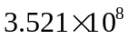and EV is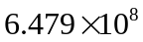.In the case of same initial energy consumption, transportation energy consumption for the year is
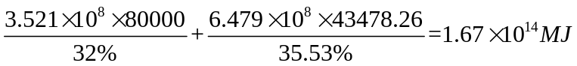.
So after widespread use of EV, the total calorific of oil-saving isin the world and the saving ratio is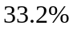.
3.3.3 The third question of the model: the maximum amount of power and type of benefit cases
In the first question, we think about overall efficiency obtain the rate between electric vehicle and motor vehicle is 0.5722:0.4278, In the second question, we take 2011 as the example, the total amount of 1000 millions global automotive, so we could draw the conclusion that in total to produce the maximum benefit of environmental, social, business and personal to use electric cars to 572.2 millions cars, the global total number of total vehicle 57.22%.
According to the introduce from Baidu Encyclopedia, the electric vehicle is a car that being powered by a car power，driving the wheel by using the motor，comply with the road traffic safety laws and regulations requirements. According to drive mode can be divided into pure electric vehicles, hybrid electric vehicles, fuel cell electric vehicle.
Table 11. the classification about EV
electric vehicle | Blade Electric Vehicles | Motor drive
electric vehicle | Hybrid electric vehicle | Fuel machine, motor drive
electric vehicle | Fuel cell electric vehicle | Fuel cell drive

According to the different types of electric vehicle, we decide to use AHP to analyze the problem, to Different kinds of electric vehicles on the environment, we could discuss from environmental, social, business and personal, As shown in Figure 4 :
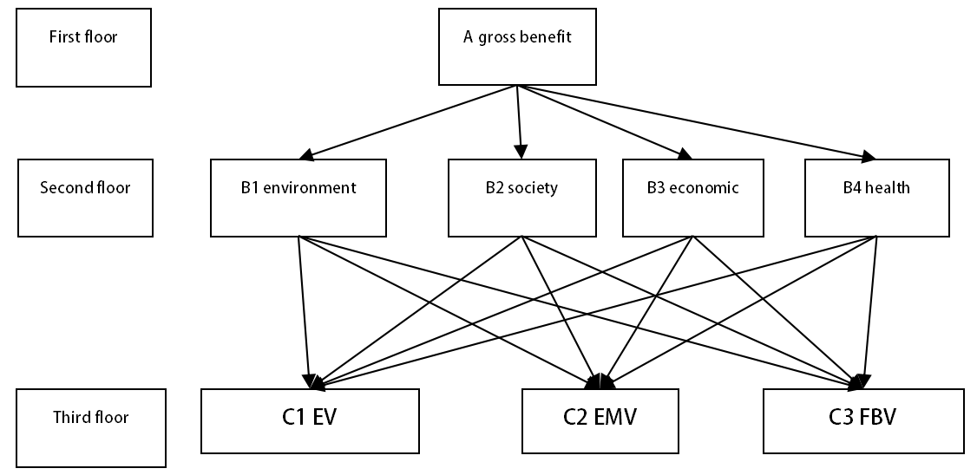
Figure 4. Automobile category AHP map
AHP, the four aspects in the second floor make same efface to the first floor, according to the actual situation analysis, decision matrix of the third floor is that：
Table 12. the decision matrix of the third floor
B1 | C1 | C2 | C3 |  | B2 | C1 | C2 | C3
C1 | 1 | 3 | 1/3 |  | C1 | 1 | 3 | 3/5
C2 | 1/3 | 1 | 1/9 |  | C2 | 1/3 | 1 | 1/5
C3 | 3 | 9 | 1 |  | C3 | 5/3 | 5 | 1
B3 | C1 | C2 | C3 |  | B4 | C1 | C2 | C3
C1 | 1 | 5/3 | 5 |  | C1 | 1 | 7/5 | 7/9
C2 | 3/5 | 1 | 3 |  | C2 | 5/7 | 1 | 5/9
C3 | 1/5 | 1/3 | 1 |  | C3 | 9/7 | 9/5 | 1
According to the dates given above, we can see the B1, B2, B3 and B4 pass the consistency check.
Figure 13. The total level of the right sort of vector
 | CI | CR | W
B1 | 4.4409e-16 | 7.6567e-16 | {0.2308,0.0769,0.6923}
B2 | 2.2204e-16 | 3.8284e-16 | {0.3333,0.1111,0.5556}
B3 | 0 | 0 | {0.5556,0.3333,0.1111}
B4 | 4.4409e-16 | 7.6567e-16 | {0.3333,0.2381,0.4286}

According to the data from table 8, we can get the value of C1,C2, C3 respectively is: 0.3633，0.1898，0.4469. it means that in all kinds of distribution of electric vehicle, Pure electric cars should be accounted for 36.33%, hybrid electric vehicle should be accounted for 18.98%, fuel cell vehicles should be 44.69%. That is, in the total amount of electric vehicles for 572.2millions cars, pure electric cars should be accounted for 207900000 vehicles, hybrid electric vehicles should be accounted for 108.6millions vehicles, fuel cell vehicles should be accounted for 255.7millions
According to the number of electric cars the global optimal, comprehensive benefits more subdivided into categories. we can calculate the total global annual prospective power. the classification of electric vehicles belonging to automobile professional knowledge, here we assume that the driving energy of 100% pure electric vehicles from the external supply of electric power, 50% mixed driving energy dynamic electric vehicle from an external supply of electric power, and fuel cell vehicles driving energy from an external supply of electric power. Therefore, We can briefly calculate all electric cars in purely external electricity supply vehicle number is
According to the data^{[8]}, the VE( Tesla ), The electric power consumption is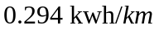, by the previous data, an electric car running 20000km a year, so it can be worked out 264 millions electricity consumption in one year:
So , In three types of electric cars in the total amount of 572.2 million, it will consume1.5510¹²degree electricity.
All in all, in the global 10000 million, if the pure electric cars should be accounted for 207.9 million vehicles, hybrid electric vehicles should be accounted for 108.6 million vehicles, fuel cell vehicles should be account for 255.7 million, then can produce the greatest benefit for environment society, business and personal, and at the same time, the global total power capacity to increase the degree of electricity.
When the amount of the three types of electric car are 5.722 hundred million, We need to consume 1.551012kwh every year.
In summary, in the case of that the amount of global car are 10 hundred million. The electric vehicle should be accounted for 2.079 hundred million, The hybrid electric vehicle should be accounted for1.086 hundred million, The Fuel cell vehicle should be accounted for 1.086 hundred million. if that it will to produce the maximum benefit of environmental, social, business and personal. At the same time, the increase electricity in global should increase.to 1.551012kwh.
According to the power generation type, shown follow:
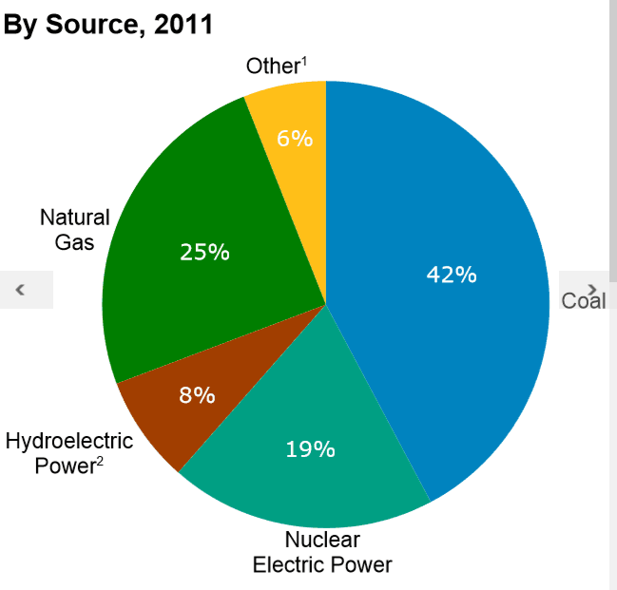
Figure 5. The power generation by source
we think about 5 types, it’s Coal，Gas，Nuclear，H power，other；we use AHP to discuss this problem.
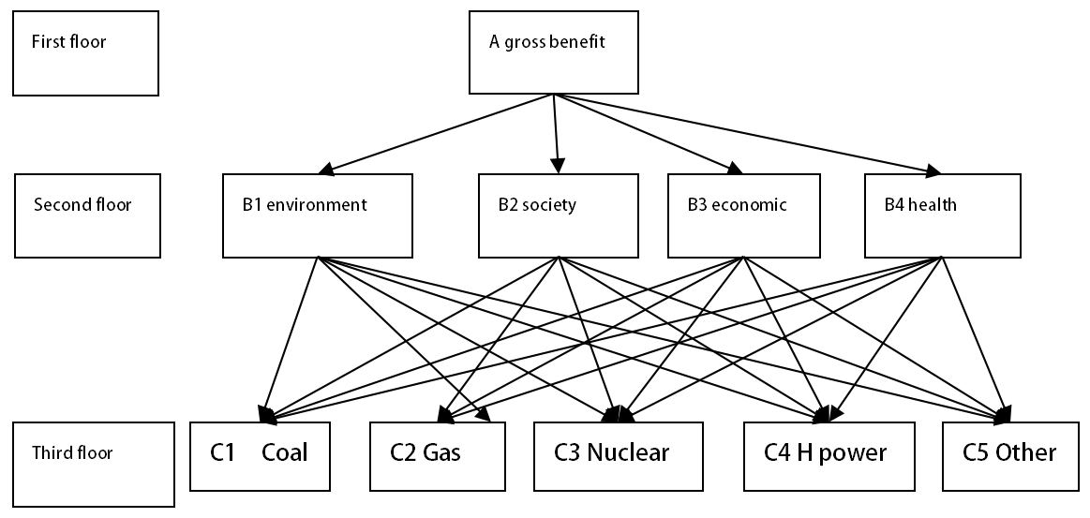
Figure 6. The AHP map of fuel material types
The four aspects in the second floor make same efface to the first floor, the second layer is the judgment matrix
Table 14. the judgment matrix of the second layer
B1 | C1 | C2 | C3 | C4 | C5 |  | B2 | C1 | C2 | C3 | C4 | C5
C1 | 1 | 1/3 | 1/5 | 1/7 | 1/7 |  | C1 | 1 | 1/5 | 1/5 | 1/7 | 1/5
C2 | 3 | 1 | 3/5 | 3/7 | 3/7 |  | C2 | 5 | 1 | 1 | 5/7 | 1
C3 | 5 | 5/3 | 1 | 5/7 | 5/7 |  | C3 | 5 | 1 | 1 | 5/7 | 1
C4 | 7 | 7/3 | 7/5 | 1 | 1 |  | C4 | 7 | 7/5 | 7/5 | 1 | 7/5
C5 | 7 | 7/3 | 7/5 | 1 | 1 |  | C5 | 5 | 1 | 1 | 5/7 | 1
B3 | C1 | C2 | C3 | C4 | C5 |  | B4 | C1 | C2 | C3 | C4 | C5
C1 | 1 | 5/7 | 5 | 5 | 5 |  | C1 | 1 | 1/3 | 1/5 | 1/9 | 1/5
C2 | 7/5 | 1 | 7 | 7 | 7 |  | C2 | 3 | 1 | 3/5 | 1/3 | 3/5
C3 | 1/5 | 1/7 | 1 | 1 | 1 |  | C3 | 5 | 5/3 | 1 | 5/9 | 1
C4 | 1/5 | 1/7 | 1 | 1 | 1 |  | C4 | 9 | 3 | 9/5 | 1 | 9/5
C5 | 1/5 | 1/7 | 1 | 1 | 1 |  | C5 | 5 | 5/3 | 1 | 5/9 | 1

Pairwise comparison matrix B1, B2, B3, B4, we Can ask of the total order weight vector and consistency tests, the results are as follows
(W is normalized vector):
Table 15. the results
 | CI | CR | W
B1 | 0 | 0 | {0.0435,0.1304,0.2174,0.3043,0.3043}
B2 | 0 | 0 | {0.0435,0.2174,0.2174,0.3043,0.2174}
B3 | -4.4409e-16 | -3.9651e-16 | {0.3333,0.4667,0.0667, 0.0667,0.0667}
B4 | -2.2204e-16 | -1.9825e-16 | {0.0435,0.1304,0.2174,0.3913,0.2174}
The weight of C1 is
By computer program：the weight of C1, C2, C3, C4, C5 is 0.1160, 0.2362, 0.2232, 0.2667, 0.2015.
Therefore, to produce the maximum benefit of environmental, social, business and personal power type as shown in new energy proportion, which accounts for the largest proportion, so in the future should focus on new energy power generation.
3.3.4 The model of requirement 4: For electric vehicle battery problem
In the face of increasing global oil supply shortage of fuel, the widespread use of electric vehicles can solve the problem of global energy demand to a certain extent. But when we vigorously promote the electric vehicle, with charging problem, and the security problem, efficient transportation problem is also should be considered.
Although electric vehicles compared to conventional vehicles, does not require fossil fuels as power, and environmental problems that are not caused by the exhaust pollution, but because of electric vehicles to use high-energy batteries, and now the battery life of electric vehicles are not very long, so the widespread use of electric vehicles will inevitably produce large amounts of waste batteries.
We know that the current electric vehicle battery use high-energy lithium battery on the related literature. Many people believe that lithium is a "Green Battery", it will not cause environmental pollution after the spent lithium ion batteries discarded. But in fact, the lithium-ion battery will not be truly "green batteries." If used lithium-ion batteries without effective treatment, it will resulting in greater pollution on the environment ^{[8]}.
Study found the same problem situation at home and abroad, China has promulgated the "communication with the lithium-ion battery recycling requirements" (GB / T 22425-2008), but as a recommended standard has not been really implemented. Clearly, there is a large gap compared with developed countries. For example, the European Union was May 2, 2007 by a directive from 2008 onwards require mandatory recycling of used batteries; beginning in 2009, sold in the EU have marked the life of the battery; before 2012, the EU 25 % of used batteries must be recycled by 2016 should reach 45%. New York State recently passed a new legislation that requires battery manufacturers, including importers, and retailers to work together to establish a free and convenient recycling system to its sale or distribution of rechargeable batteries. In addition, our current new energy vehicles that the policy to support large, but for the lithium-ion battery scrap recycling industry is still not introduced effective policies. This is a direct result of the current waste treatment and disposal of lithium-ion batteries can not form the industrial scale. Not a national waste processing companies to really go lithium industrial management of the road, of course, is not the possibility of profit.
For electric vehicle charging time questions:
According to the needs of users of electric vehicle car habits, work time and guide policy, and the charging type electric car set piece scenes. In the study, we can be set up from the angle of power grid operators, we can also consider the convenient of EV users to set. The influence of different charging time to the power network is very large, if we charge in the peak hours ,we will aggravate the burden of power grid, and if in non peak hours to charge, we will reduce the charge of the impact to grid^{[9]}.
Based on the above research investigation, We put forward the following two Reasonable suggestions:
In the study:
Give electric vehicle research more financial support, particularly, the government needs to promote electric vehicles and the corresponding power infrastructure development and research projects with investment.
Give the battery technology and Research on improving the charging capacity of battery financial support.
Given the research of renewable and nuclear energy and development funding support because renewable energy and nuclear energy can reduce emissions and save fossil fuel.
In policy areas:
In the implementation phase of the development of electric cars, we should provide electric car drivers for Financial support.
Develop appropriate car tax system to promote low-carbon vehicles and without the use of petroleum development.
Give the electric vehicle battery production and Power supply infrastructure deployment subsidies.
3.4 Improved Model
3.4.1 The advantages of the model
In the subject, we use the simple model to solve problem quickly, and the results is friendly. At the same time, using the analytic hierarchy process (a h p), and considering the index, we formulate our final calculation and analysis about the total benefits of the best cases and the weight of each index. This problem use this method to do which it is not easy to make reasonable analysis and qualitative analysis, quantitative analysis of the model is reasonable, obtained and get a satisfactory results.
3.4.2 The disadvantage of the model
The problem`s data is short, the study can not be completely representative of all vehicle models. And in a number of AHP process does not optimize it. Vehicle handled herein are just one of thousands of vehicles, as we will representatives which do not fully comply with the actual situation. it can be considered in more models to do a sample survey on behalf of car types to obtain a more realistic situation. Meanwhile, when calculating the three indicators of the process, we can consider a longer period of time to obtain data from a large number of statistics, analyze data, obtain more accurate data value.
VI. References
[1] ANWB. http://www.anwb.nl/.
[2] Annual Energy Review 2011. http://www.eia.doe.gov/aer/pecss_diagram.html.
[3] http://inf.315che.com/n/2009_02/81787/.
[4] 刘晓光. 汽车污染途径与控制措施的研究[J]. 漯河职业技术学院学报, 2012.02.40-41.
[5] 司守奎. 数学建模算法与程序. 海军航空工程学院. 2007.9.
[6] The official website of electric vehicle at China. http://news.ddc.net.cn/newsview_47640.html.
[7] Baidu encyclopedia. http://baike.baidu.com/link?url=sCbQNApRRnms5bStMTnTbtgGeg0GtEPKTNCBupAw0XU1iWvfzeFTw9WdUFTcR51FGJE_27zzbR7pQjQLJfZjcq.
[8]戴长松, 路密熊, 岳平, 江洪伟. 废旧锂离子电池处理处置现状及污染防治对策.
[9] Environmental science and technology. 2013.S2:332-335+401.
[10]高赐威, 张亮. 电动汽车充电对电网影响的综述[J]. 电网技术. 2011.02:127-131.
VII. Appendix
Programs and codes

